EMMA Optimization – P&D
IP22 Device modification EMMA correction in GCM
SAP EMMA
PJT12065

Analyst: Sri Ravula

History of Changes

Rev. | Date | Modified by | Comments
1.0 | 10/17/2016 | Sri Ravula | Initial Draft
2.0 | 10/21/2016 | Sri Ravula | Review

Success Criteria
Eliminate the need to resolve IP22 EMMA cases for device modification reads for GCM module install

This happens in the scenario there is no customer to bill (current occupant) or consumption (just a device modification read) to bill for and therefore no need to create a EMMA case

Business/Sponsor Requirements

Device modification reads should not be considered consumption

When Corrix vendor installs the new GCM, the first read that comes through is a 0, but then the next read shows the meter value, SAP assumes that 0-X is the consumption seen for that period, but it really has not changed.

All disconnected gas meters with no customer, upon a GCM install, there appears as though there is consumption, but with no customer to bill to, an IP22 is created

Stakeholder Requirement A.
Eliminate the need to resolve IP22 EMMA cases for device modification reads for GCM module install when there is no customer to bill (current occupant) or consumption (just a device modification read) to bill for and therefore no need to create a EMMA case

Production ECP Example:
_______________________________________________________________________________________
Please see the example below. In this example you can see that this meter now has a GCM as the device was exchanged and is now a 90000000 number which is indicative of a smart meter. You can see that there has be no use on this meter prior to and after the exchange. The IP22’s where this scenario exists should not be created.

EMMA Case Number: 10298774
Installation Number: 5000037760

Read History:
Installation Meter reading reason Meter reading type Device Equipment Unit of meas for MR Predecimal Places in Meter Reading Created on
5000037760 1 01 92443163 100006474688 CCF 6364 9/8/2016
5000037760 1 01 92443163 100006474688 CCF 6364 8/9/2016
5000037760 1 01 23349798 100000446851 CCF 6364 7/11/2016

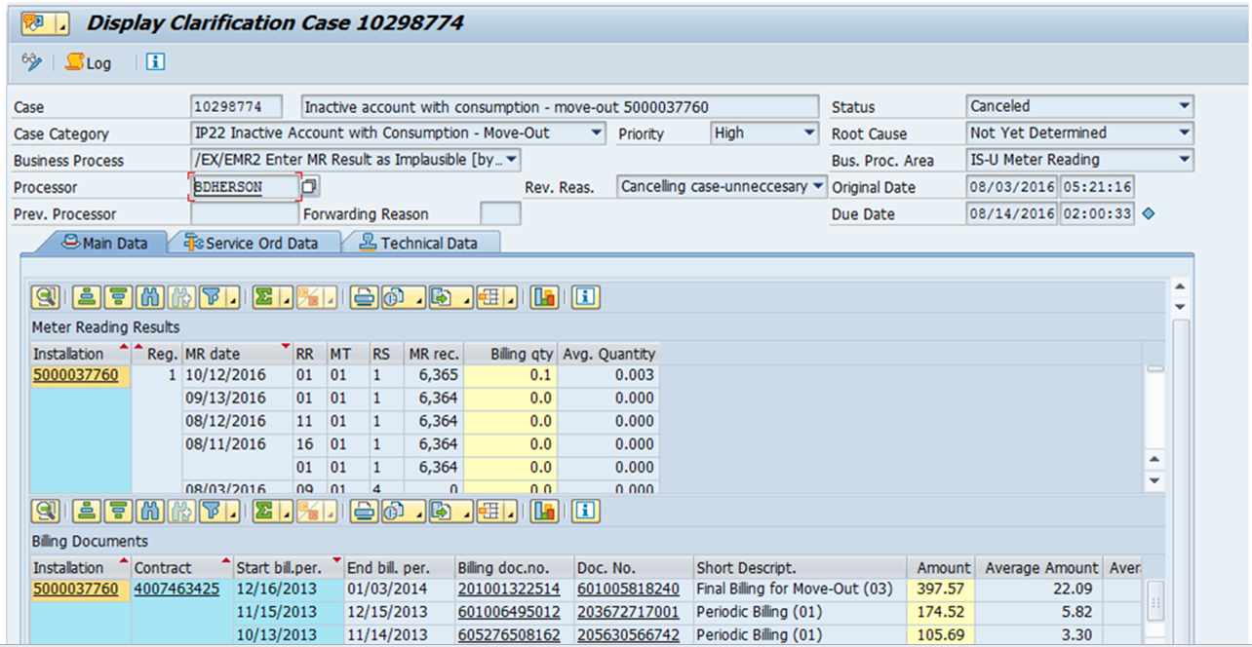
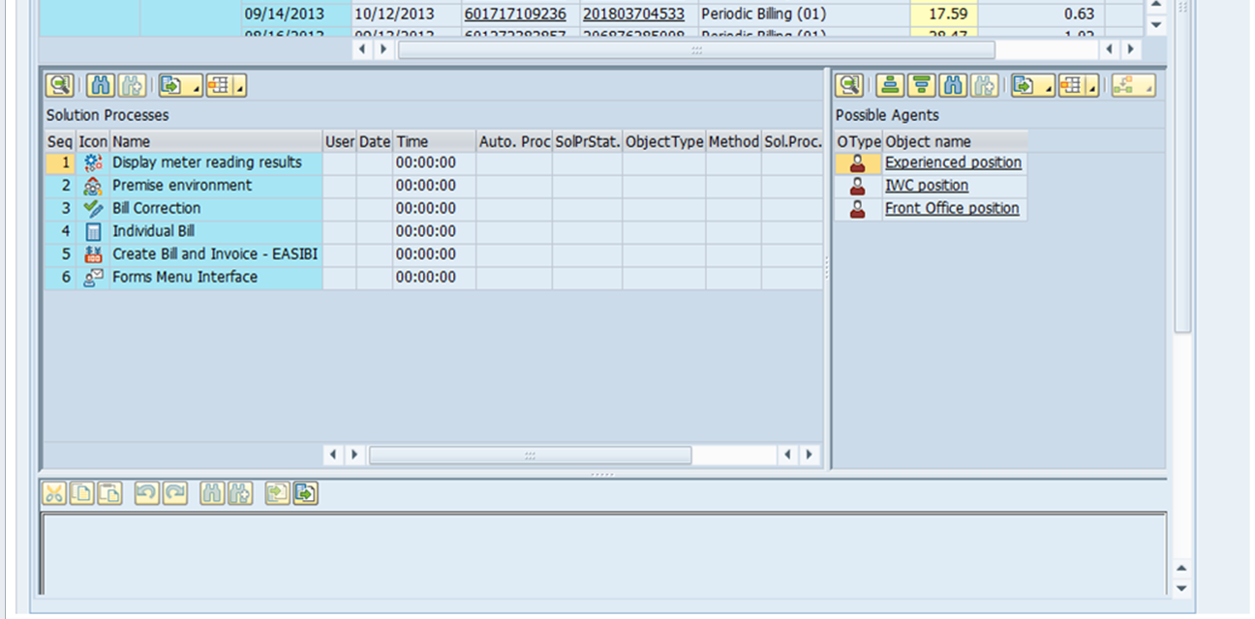

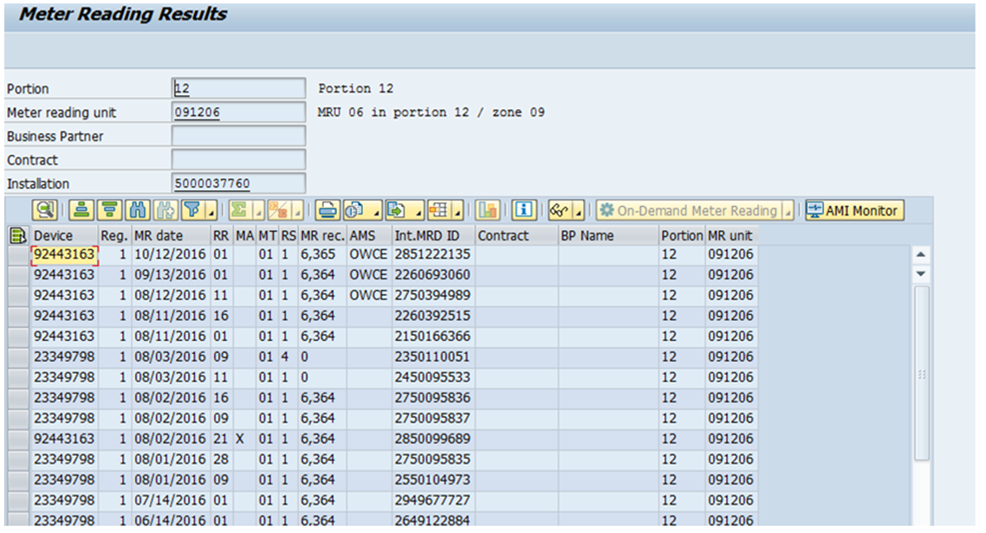
_________________________________________________________________________________________________

Solution (Functional) Requirement A.1

EMMA Configuration - Transaction EMMACCAT2
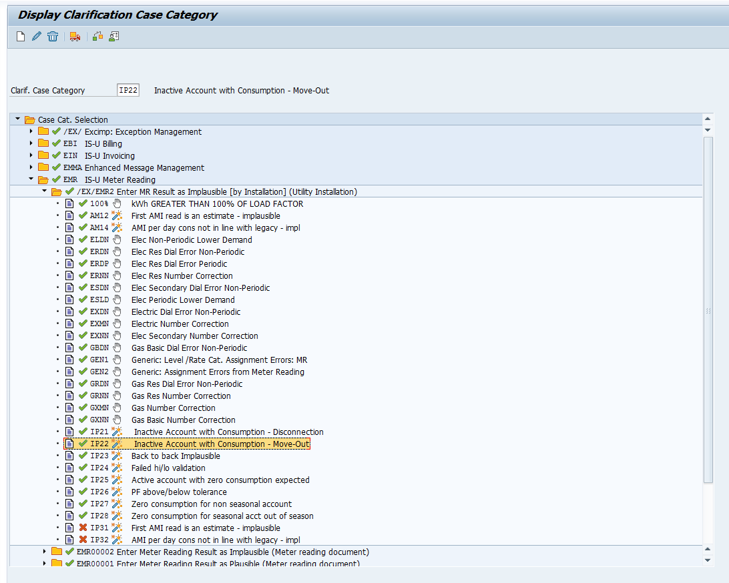

Case Category IP22
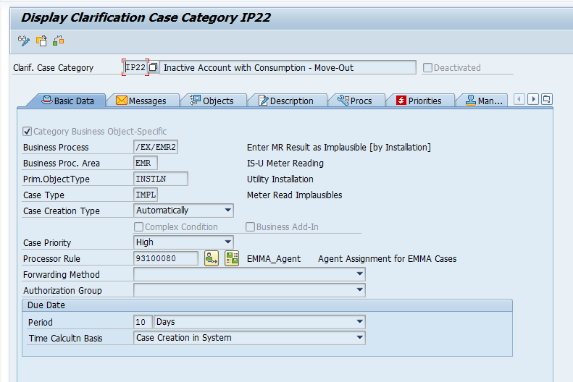

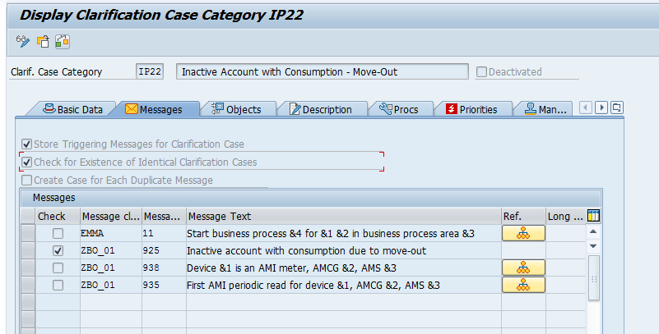

Technical Object:
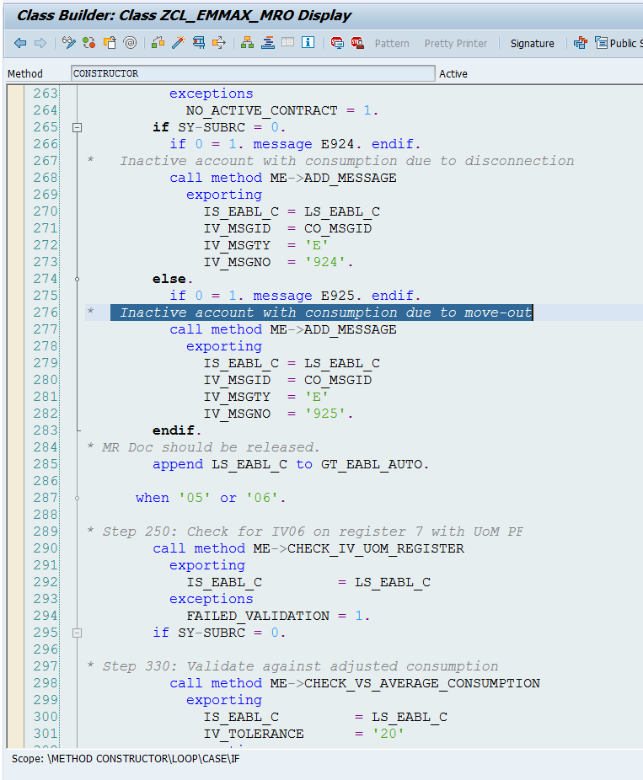

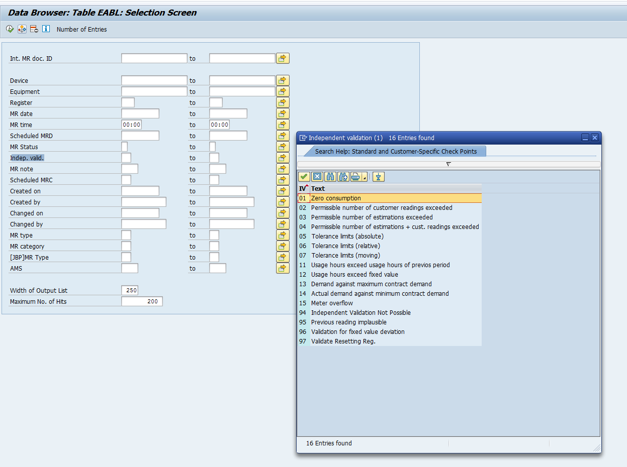

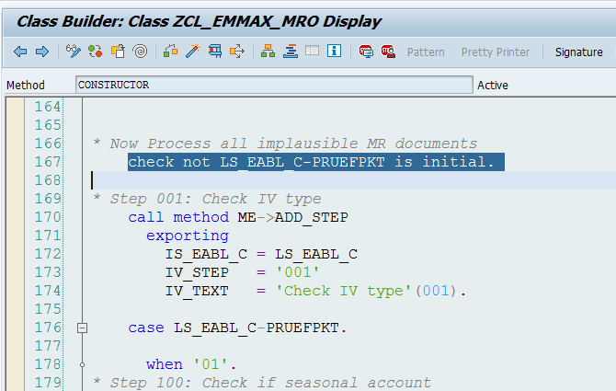

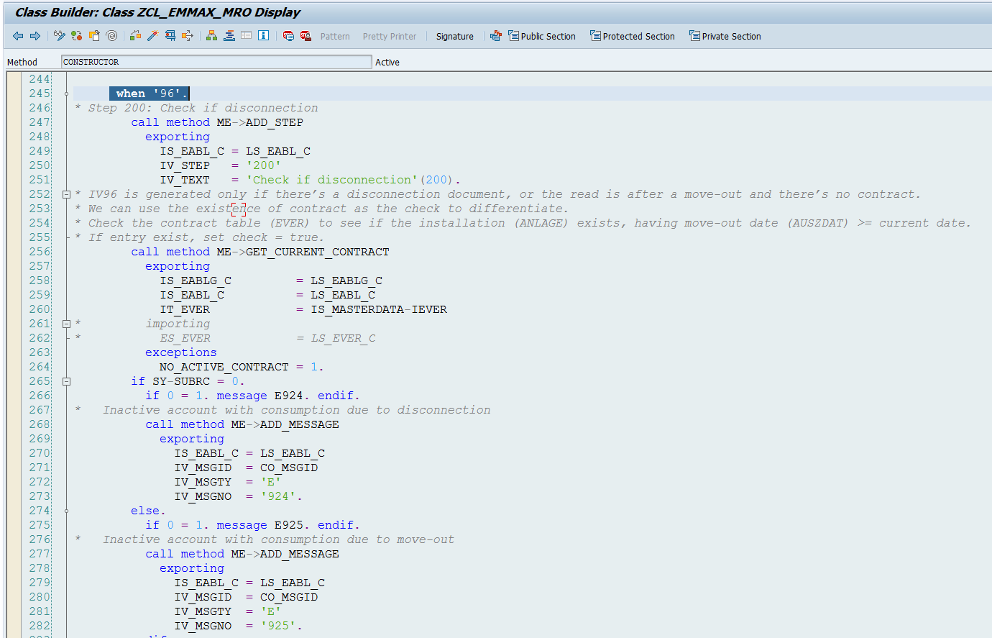

The below logic need to be incorporated into the above Method.
IP22 EMMA case should not be triggered for the following:

If device from GCM (Gas connection module)
If device now is smart meter (starting with 9)
If there is no customer (business partner) associated with installation/meter read
If previous meter reads goes from non-zero to zero to non-zero (which is same read as previous read before zero)
Then do not create IP22 EMMA case.
Endif.
Endif.
Endif.
Endif.

Testing Considerations

Sr. No. | Test Case | Expected results
1
2

Additional Considerations (Optional)
(don’t forget about these – create a full section if needed or include in existing sections above) | Notes/Detail (ref. docs, details, elaboration, contacts, etc)
Storage | Space for data, apps, etc; Consider multiple landscapes
Servers, Hardware | AST/Servers, devices, etc
Database | ORADBA
Performance & Capacity | Performance testing, risks, impact, network bandwidth, etc
Cyber Security
Vendor Management | Involvement in change, support, design assistance,
Environment/Landscapes | (prep, connectivity, other projects, timing, etc)
Impacts | to other Teams, Systems, Apps, Objects, etc.
Access | roles, AD groups, application access, different environments, etc
Security | passwords (people & programs), firewall, t-codes, etc
PI/XI alignment
Implementation/Cutover | timing, outages, tasks and sequence, contingency plan, conflict with other activities, etc
Web needs | Internet bandwidth, development, etc
BI/Reporting
Auditing | logging, controls
File Moves | BizTalk
Archiving | Data & file archiving, purging, retention, etc
Notifications – | Spool, email, pager, workflow, etc
Support Level | On-call, 24x7 vs business day, EARL/SM7 set up, etc
Distribution | Medic Packaging, etc
Training | Formal training, job aids, procedures; include for both end user and project/support staff
Communication
Manual Configuration, table changes | Timing; Authorization; Access;
Software/Licensing | Also yearly maintenance costs & considerations
Job Prose, Help Desk guidelines
Availability of the system | Planned & unplanned outages, disaster recovery, criticality
Skill needs | Include in each design section if possible – ABAP, web development, GIS, Oracle, etc
Conversion/Data Cleansing
Risks & Assumptions: This section should include things like predecessors, scope clarification, dependencies, resource expectations, etc. These may relate both to business issues and system design issues.
Constraints: This section should list all the constraints under which the solution has been designed. E.g. a certain database type must be used, Enterprise Architecture says we must do this way, cannot do VMware, etc

Risks | Description
Assumptions | Description
Constraints | Description

Supporting Documentation

Solution Design Document Validation/Approval

Name | Comments | Date

